1. Write a MapReduce/Pig program to calculate the number of cases investigated under each

FBI code

Loading the Data set Crimes in HDFS

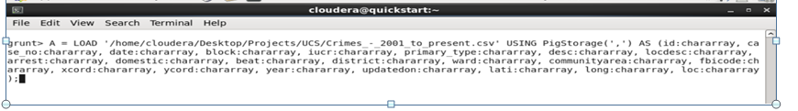

Dumping A to see the records.

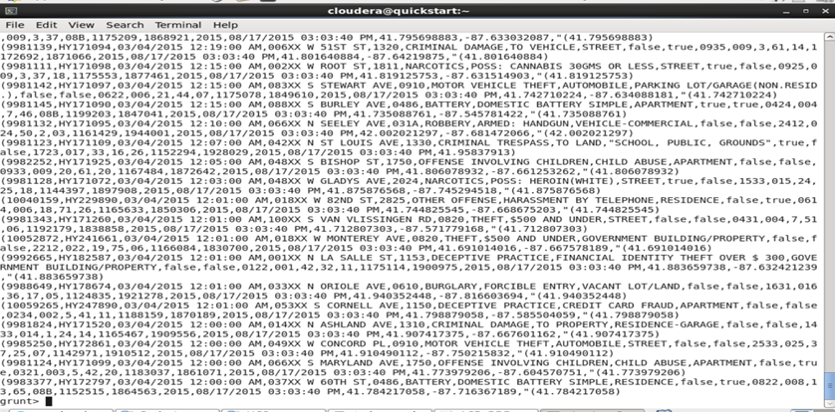

Grouping the record by fbicode



Dumping B to See grouped records.

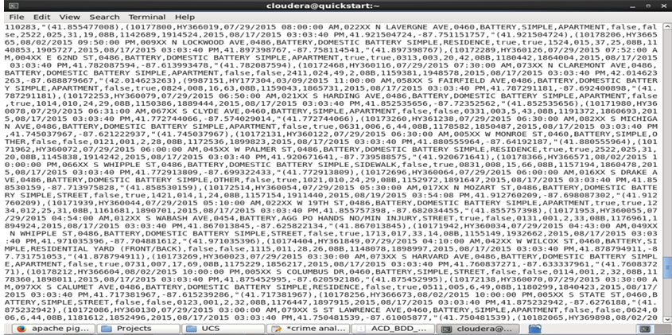

Counting the no of cases investigated for each FBI Code



Dumping C to see the No of Cases investigated under each FBI Code.

